Sprint-4

**Train The Model On IBM**

**Train The Model on IBM Watson**

|  |  |
| --- | --- |
| Date | 15 Nov 2022 |
| TeamID | PNT2022TMID35444 |
| ProjectName | Classification of Arrhythmia by Using Deep Learning with 2-D ECG Spectral Image Representation |

TASK:

Train The Model on IBM Watson:

GO ON WATSON SERVICES(SCREEN SHOT):

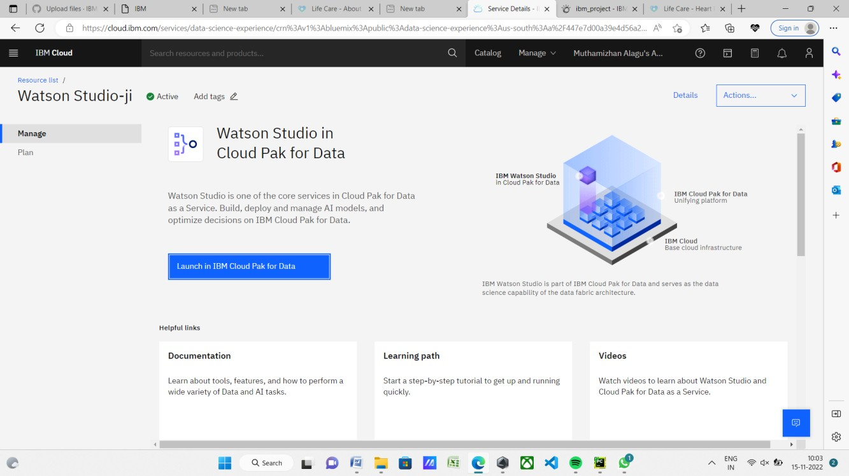

GO ON NEW PROJECT (SCREEN SHOT):

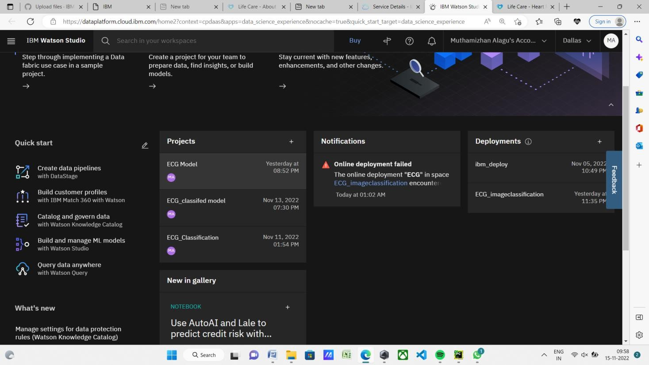

GO ON ASSEST(SCREEN SHOT):

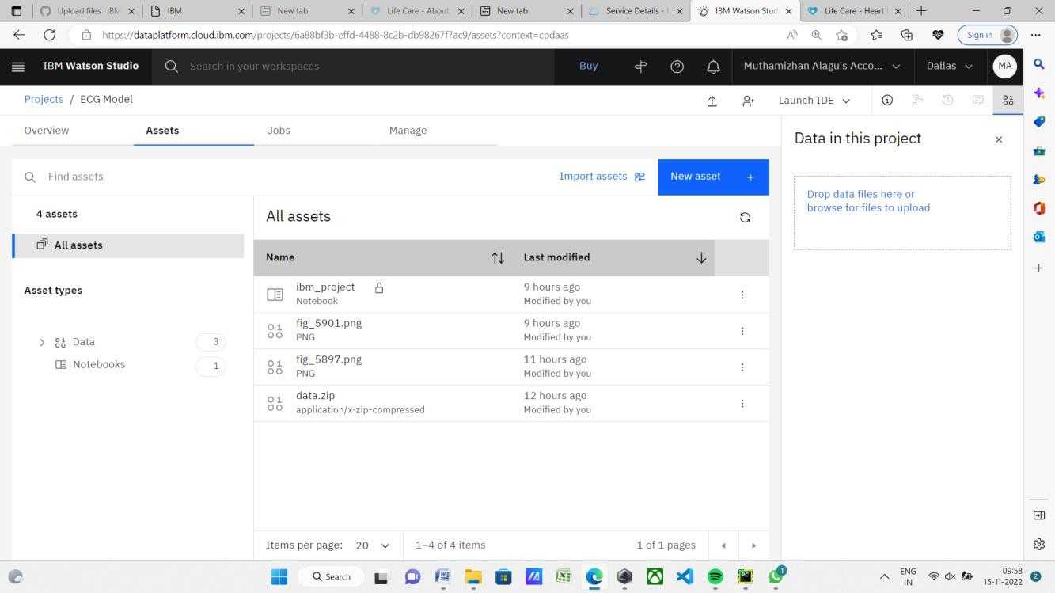

GO ON IBM_PROJECT(SCREEN SHOT):



JUPYTER NOTEBOOK(SCREEN SHOT):

